Lewis University
CPSC 50900: Database Systems
Spring 2023 Term Project

FASHION STORE DATABASE PROJECT

Hruthasan Mallala
HruthasanMallala@lewisu.edu
GitHub: https://github.com/Hruthasan/FASHION-STORE-DATABASE-PROJECT.git

Index:
- Composite index on Order table for CustomerID and DeliveryPartnerID:
SQL Query:
CREATE INDEX indx_order_customer_deliverypartner ON Orders (CustomerID, DeliveryPartnerID);
This index would be useful when querying orders by customer or delivery partner. It would allow for faster retrieval of orders for a particular customer or delivery partner, reducing the need for full table scans.
- Index on the Product table on the WarehouseID column:
SQL Query:
CREATE INDEX indx_product_warehouse_id ON Product (WarehouseID);
This index would be useful when querying products by warehouse.The warehouse data is frequently accessed along with the product data. . It would allow for faster retrieval of products for a specific warehouse, reducing the need for full table scans.

- Composite index on the Order_Product table on the OrderID and ProductID columns:
SQL Query:
CREATE INDEX indx_order_product ON Order_Product (OrderID, ProductID);
This index will help speed up queries that involve searching for all products associated with a specific order. It would allow for faster retrieval of products, reducing the need for full table scans.

To demonstrate the impact of these indexes on the performance of various queries, I would run before-and-after benchmarks on a set of representative queries.
For example:
>> SELECT * FROM Orders WHERE CustomerID = 1 AND DeliveryPartnerID = 3;
>> SELECT * FROM Product WHERE WarehouseID = 456;
>> SELECT * FROM Order_Product
JOIN Order ON Order_Product.OrderID = Order.OrderID
WHERE Order.CustomerID = 1;

Views:
- CREATE VIEW Order_Customer_Info AS
SELECT Order.OrderID, Order.OrderQuantity, Order.OrderInformation, Customer.Name, Customer.Address, Customer.PhoneNumber
FROM Order
INNER JOIN Customer ON Order.CustomerID = Customer.CustomerID;
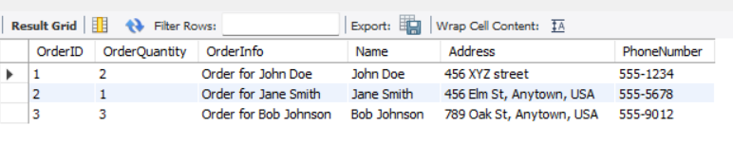
This view combines data from the Order and Customer tables, allowing for easy access to order information along with customer information. This can be useful when analyzing orders and customer behaviour.
- CREATE VIEW StoreInventory AS
SELECT s.StoreID, s.StoreName, s.Address AS StoreAddress, p.ProductID, p.ProductName, p.Brand, p.Cost, p.Size, p.Material, sp.Quantity
FROM Store s
JOIN Store_Product sp ON s.StoreID = sp.StoreID
JOIN Product p ON sp.ProductID = p.ProductID;
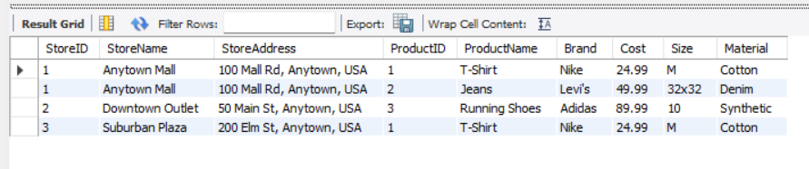
This view combines data from the Store, Store_Product, and Product tables, providing a comprehensive overview of the inventory at each store.
These views are valuable additions to the database because they provide an easy way to access and combine information from multiple tables. They can be used to quickly get a comprehensive overview of the order details and store inventory in a single view, which can be useful for various tasks such as inventory management, order tracking, and reporting.

Triggers:
DELIMITER $$
CREATE TRIGGER trg_product_added
AFTER INSERT ON Product
FOR EACH ROW
BEGIN
UPDATE Warehouse
SET StorageCapacity = StorageCapacity + NEW.Size
WHERE Warehouse.WarehouseID = NEW.WarehouseID;
END$$
DELIMITER ;
The purpose of this trigger is to update the StorageCapacity of the Warehouse table whenever a new product is added to the Product table. The trigger fires after a new row is inserted into the Product table and retrieves the size of the new product (NEW.Size) and the corresponding WarehouseID (NEW.WarehouseID). It then updates the StorageCapacity of the Warehouse with the corresponding WarehouseID by adding the size of the new product to the current value.

INSERT INTO Product (ProductName, Brand, Cost, Size, Material, WarehouseID)
VALUES ('Charger', 'Samsung', 1000, 15, 'Aluminum', 1);-
Before trigger:
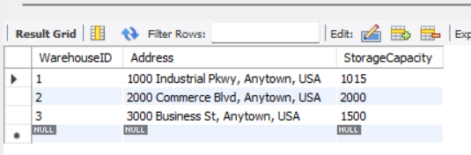
After trigger:
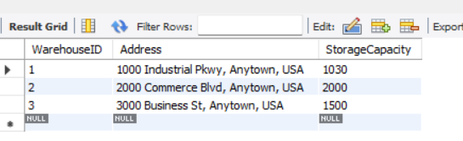

Transactions:
Transactions are important for ensuring ACID behavior, which stands for Atomicity, Consistency, Isolation, and Durability.
Atomicity ensures that a transaction is treated as a single unit of work, which either completes in its entirety or is rolled back to its previous state if any part of it fails. Consistency ensures that the database remains in a consistent state before and after a transaction, regardless of whether the transaction succeeds or fails. Isolation ensures that multiple transactions can be executed simultaneously without interfering with each other. Durability ensures that once a transaction is committed, its effects persist even if there is a system failure.
Here is an example of a MySQL transaction:
START TRANSACTION;
UPDATE Product
SET Cost = 1200
WHERE ProductID = 1;
UPDATE Warehouse
SET StorageCapacity = StorageCapacity - 10
WHERE WarehouseID = 1;
COMMIT;
Before Transaction:
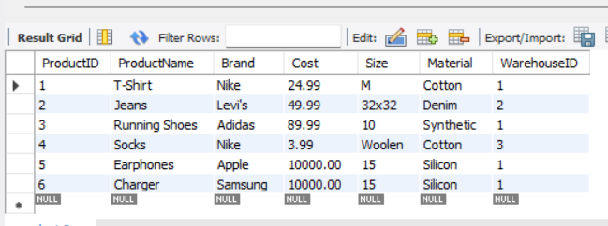
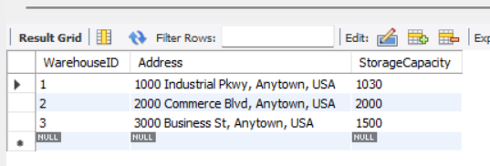
After Transaction:
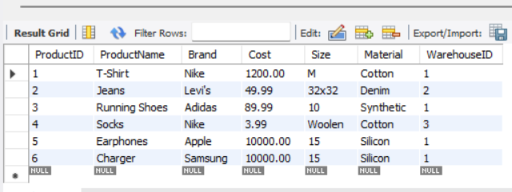
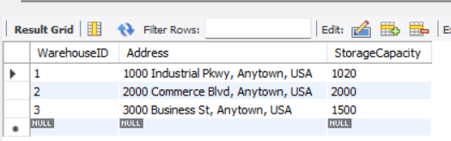
As we can see, the cost of the product with ProductID 1 has been updated to 1200, and the StorageCapacity of the warehouse with WarehouseID 1 has been reduced by 10. These changes were made atomically and consistently, and the transaction was isolated from any other transactions that may have been running concurrently. Finally, the effects of the transaction are durable and will persist even in the event of a system failure.
Security:
Based on the design of the database, there are several types of users who may use the database:
- System administrators - They will have complete control over the database.
- Warehouse managers - They will be responsible for managing the inventory stored in the warehouse.
- Store managers - They will be responsible for managing the inventory and orders for their store.
- Delivery partners - They will be responsible for delivering the orders to customers.
- Customers - They will be able to view their order history and personal information
System Administrators:
CREATE USER 'sysadmin'@'localhost' IDENTIFIED BY 'mkyt1234';
GRANT ALL PRIVILEGES ON *.* TO 'sysadmin'@'localhost';
This statement grants all privileges on all databases to the user 'sysadmin' on the local machine.
Warehouse Managers:
CREATE USER 'warehouse_mgr'@'localhost' IDENTIFIED BY 'mkyt123';
GRANT SELECT, INSERT, UPDATE ON Product TO 'warehouse_mgr'@'localhost';
GRANT SELECT, INSERT, UPDATE ON warehouse TO 'warehouse_mgr'@'localhost';
GRANT SELECT, INSERT, UPDATE ON order_product TO 'warehouse_mgr'@'localhost';
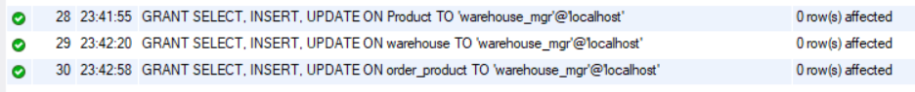
This statement grants the user 'warehouse_mgr' on the local machine the privileges to select, insert, and update data in the Product, Warehouse, and Order_Product tables.
Store Managers:
CREATE USER 'store_mgr'@'localhost' IDENTIFIED BY 'mkyt12';
GRANT SELECT, INSERT, UPDATE ON Product TO 'store_mgr'@'localhost';
GRANT SELECT, INSERT, UPDATE ON Store_Product TO 'store_mgr'@'localhost';
GRANT SELECT, INSERT, UPDATE ON Orders TO 'store_mgr'@'localhost';
GRANT SELECT, INSERT, UPDATE ON Order_Product TO 'store_mgr'@'localhost';
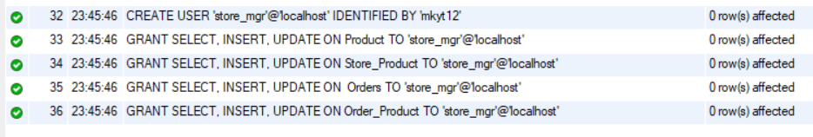
This statement grants the user 'store_mgr' on the local machine the privileges to select, insert, and update data in the Product, Store_Product, Order, and Order_Product tables.
Delivery Partners:
CREATE USER 'delivery_partner'@'localhost' IDENTIFIED BY 'mkyt1';
GRANT SELECT, UPDATE ON Orders TO 'delivery_partner'@'localhost';
GRANT SELECT, UPDATE ON Customer TO 'delivery_partner'@'localhost';
This statement grants the user 'delivery_partner' on the local machine the privileges to select and update data in the Order and Customer tables.
Customers:
CREATE USER 'customer'@'localhost' IDENTIFIED BY 'mkyt2';
GRANT SELECT ON Customer TO 'customer'@'localhost';
GRANT SELECT ON Orders TO 'customer'@'localhost';
This statement grants the user 'customer' on the local machine the privilege to select data in the Order and Customer tables.
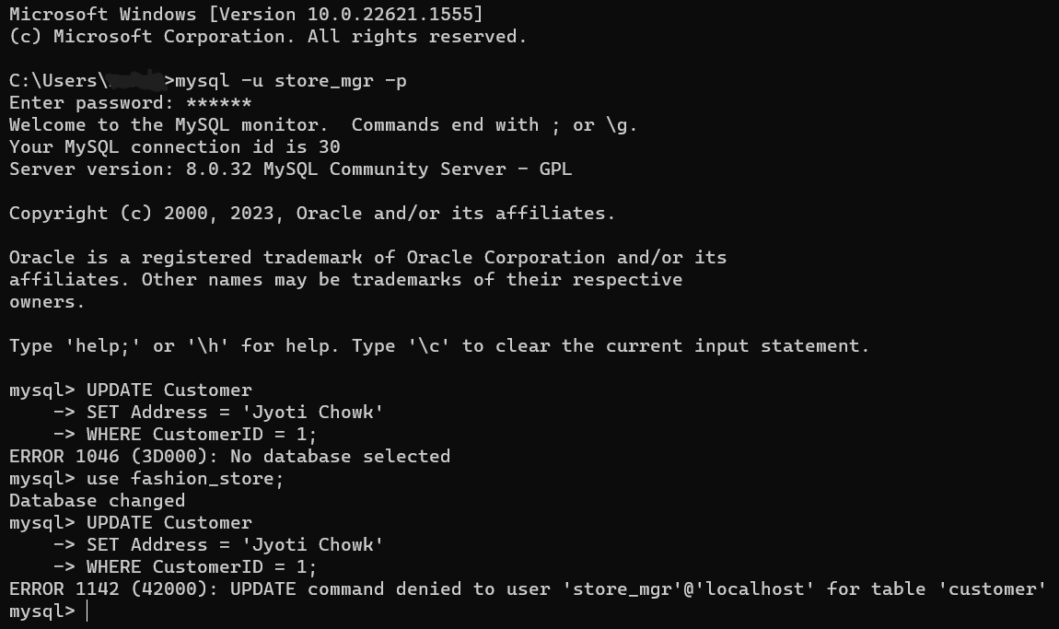
Locking:
Locking tables is a way to prevent inconsistencies in data that can arise when multiple concurrent transactions are modifying the same data simultaneously. When a table is locked, other transactions are not able to modify it until the lock is released. This ensures that each transaction has exclusive access to the data it needs to modify, which helps prevent race conditions and other issues.
For example, imagine a situation where two users are trying to modify the same row in a table simultaneously. Without locking, it's possible that one user's changes could overwrite the other's, resulting in inconsistent data. By locking the table, we can ensure that only one transaction is able to modify the data at a time, preventing this kind of inconsistency.
It's important to note that locking tables can have performance implications, as it can reduce concurrency and increase the time that transactions have to wait for locks to be released. As such, it's generally a good idea to use locking sparingly and only when necessary to prevent inconsistencies
use fashion_store;
LOCK TABLES deliverypartner READ;
DROP TABLE deliverypartner;
UNLOCK TABLES;
Backup:
Using MySQL, we can use the `mysqldump` command to create a backup of our database. Here is an example of how you can use this command:
We can also create a script that runs this command and schedule it to run at specific times using tools like cron (on Linux) or Task Scheduler (on Windows) to automate the backup process.
To schedule a backup using Task Scheduler on Windows, we can follow these steps:
1. Open the Task Scheduler by searching for it in the Start menu.
2. In the Task Scheduler, click on "Create Basic Task" in the Actions pane on the right.
3. Follow the wizard to create a new task. Give the task a name and description, and choose when you want the task to start and how often you want it to run.
4. When prompted for the action to perform, choose "Start a program".
5. In the "Program/script" field, enter the path to the `mysqldump` command. This is usually located in the `bin` directory of your MySQL installation (e.g., `C:\Program Files\MySQL\MySQL Server 8.0\bin\mysqldump.exe`).
6. In the "Add arguments" field, enter the arguments for the `mysqldump` command as explained in my previous message (e.g., `-u [username] -p[password] [database_name] > [backup_file.sql]`).
7. Complete the wizard to create the task.
Once the task is created, it will run automatically at the specified times and create a backup of your database using the `mysqldump` command. The frequency at which the backup commands will run depends on how often we schedule the task in Task Scheduler. When creating a new task in Task Scheduler, we can choose when we want the task to start and how often we want it to run. For example, we can choose to run the task daily, weekly, monthly, or at a specific time.
Securing database backups is important to prevent unauthorized access and ensure the integrity of your data. Here are some steps we can take to secure backups:
1. Encrypt backups: Encrypting backups ensures that the data is protected and can only be accessed by someone with the encryption key. We can use tools like `openssl` or `gpg` to encrypt and decrypt backup files.
2. Store backups in a secure location: Store backups in a secure location that is separate from the database server and has restricted access. This can be on a different physical server, on a network-attached storage device, or in the cloud. Make sure that access to the backup location is restricted to only authorized personnel.

3. Use secure transfer methods: When transferring backup files over a network, use secure transfer methods such as `scp` or `sftp` to ensure that the data is encrypted during transit.
4. Monitor and audit backup activity: Regularly monitor and audit backup activity to ensure that backups are being created and stored as expected. This can help detect any issues or unauthorized access to our backups.
Python Programming
Code:
import mysql.connector

# Establish a connection to the database
mydb = mysql.connector.connect(
host="localhost",
user="root",
password="mandeep",
database="fashion_store"
)

# Create a cursor to execute queries
mycursor = mydb.cursor()

# Write a SQL query to retrieve data from a table
mycursor.execute("SELECT * FROM orders")

# Retrieve the result set
myresult = mycursor.fetchall()

# Open a file to write the report to
with open("report.txt", "w") as f:
# Write a header row
f.write("ID\tName\tAddress\tPhone\n")

# Loop through the result set and write each row to the file
for row in myresult:
f.write(f"{row[0]}\t{row[1]}\t{row[2]}\t{row[3]}\n")

# Close the database connection
mydb.close()

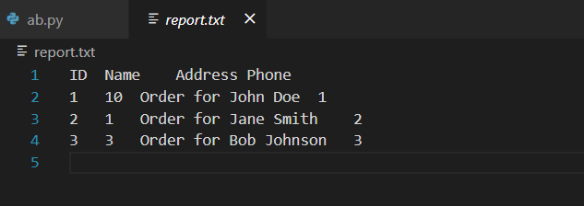

Suggested Future Work

Limitations:
1. Limited data validation and integrity: There maybe possibility that database design does not include appropriate validation rules and constraints, it may be possible for inaccurate or inconsistent data to be entered into the database. This can lead to errors and inconsistencies that can affect the reliability and usefulness of the data.
2. Limited scalability: As the amount of data stored in database grows, it may become increasingly difficult to maintain acceptable levels of performance and responsiveness. If database design does not take scalability into account, you may encounter performance issues as the database grows.
3. Limited security: Database design does not include appropriate access controls and encryption mechanisms; it may be vulnerable to unauthorized access and data breaches. This can result in the loss or theft of sensitive data, which can have serious consequences for your business.
Methods to address shortcomings:

1. Implement data validation and integrity: To ensure that the data stored in the database is accurate and consistent, we can implement appropriate validation rules and constraints. For example, we can use `CHECK` constraints to enforce data validation rules or `UNIQUE` constraints to prevent duplicate data. We can also use foreign key constraints to ensure referential integrity between related tables.
2. Design for scalability: To improve the scalability of the database, we can design it with scalability in mind from the beginning. This can include using techniques such as indexing, partitioning, or sharding to improve query performance and scalability. We can also consider using a cloud-based database service that can be easily scaled up or down to meet changing demand.
3. Implement strong security measures: To secure the database and protect against unauthorized access, we can implement strong access controls and encryption mechanisms. For example, we can use role-based access control to restrict access to sensitive data based on user roles and permissions. We can also encrypt data at rest and in transit to protect it from unauthorized access.
Migrating the database to the cloud involves moving the data and database infrastructure from local environment to a cloud-based service. This can be done using various tools and methods depending on the specific cloud service provider and database management system.
Here are some general steps that can be followed to migrate a database to the cloud:
1. Choose a cloud service provider: Selecting a cloud service provider that offers a database service that is compatible with the current database management system. Some popular cloud service providers include Amazon Web Services (AWS), Microsoft Azure, and Google Cloud Platform (GCP).
2. Prepare the data: Before migrating the data to the cloud, we may need to prepare it by cleaning, transforming, or reformatting it to meet the requirements of the cloud-based database service.
3. Export the data: Export the data from current database using a tool or method that is compatible with both current database management system and the cloud-based database service. This could involve creating a backup or dump of the data or using a data migration tool provided by the cloud service provider.
4. Import the data: Import data into the cloud-based database service using the tools and methods provided by the cloud service provider. This could involve uploading data to a storage service and then importing it into the database or using a data migration tool to transfer the data directly.
5. Test and verify: After migrating the data to the cloud, test and verify that it has been transferred correctly and that all functionality is working as expected. This could involve running queries, checking data integrity, and testing application functionality.
Here are some advantages and disadvantages of using a document-based NoSQL format:
Advantages:
- Flexibility: Document-based NoSQL databases are schema-less, meaning that we can store data without having to define a fixed schema beforehand. This allows us to easily add new data or change the structure of the data without having to modify the database schema.
- Scalability: Document-based NoSQL databases are designed to scale horizontally, meaning that we can easily add more servers to handle increased demand. This can make it easier to handle large amounts of data and support a growing user base.
- Performance: Document-based NoSQL databases can provide fast read and write performance, especially when dealing with unstructured or semi-structured data. This can make them well-suited for handling real-time data or supporting high-throughput applications.

Disadvantages:
- Data consistency: Document-based NoSQL databases do not provide the same level of data consistency and integrity as relational databases. This means that we may need to implement additional application logic or use other techniques to ensure that data is consistent and accurate.
- Complexity: Document-based NoSQL databases can be more complex to work with than relational databases, especially when it comes to querying and aggregating data. We may need to learn new query languages or use specialized tools to work with your data.
- Limited support for transactions: Document-based NoSQL databases may not provide the same level of support for transactions as relational databases. This means that we may need to implement additional application logic or use other techniques to ensure that data is updated atomically.
Activity log
11th April 2023, worked on adding indexes, views and transactions to our database.
18th April 2023, worked on security aspect for the store.
22nd April 2023, Implemented locking and backup mechanisms.
23th April 2023, worked to write python script to connect to our database.
24th of April 2023, found limitations in our project and methods to overcome them .
25th of April 2023, Written the report

